



**Obstacles**

* Limited Time to Research/Read Documentation
* After Hours to Need Help
* New Client

**Wants/Needs**

* Easy Access to Common Information
* 24 Hr Customer Assistance
* Child Lock/Security

**Savviness Scale**

(1 Star through 5 Stars)

Internet 

Streaming 

Research 

Device Variability 

**Helpful Suggestions**

Navigate the Disney+ Homepage

**Demographics**

Amelia Korning

30 Years Old

Female

New York, USA

Customer Service Representative

Associates in Communications

**Biography**

Amelia is a mother of two children; One 2 year old boy and one 5 year old girl. Currently lives in New York state and is a Customer Service Representative for a Telephone Company. Received her Associates in Communications at Caygua Community College. Amelia is a potential new Disney+ customer looking to learn how to subscribe to the service.

**Favorite Movies & Shows**

* Lion King
* The Little Mermaid
* Aladdin
* Once

**Childrens’ Favorite Movies & Shows**

* Frozen
* Zootopia
* Bluey

Contact Disney+ Customer Support

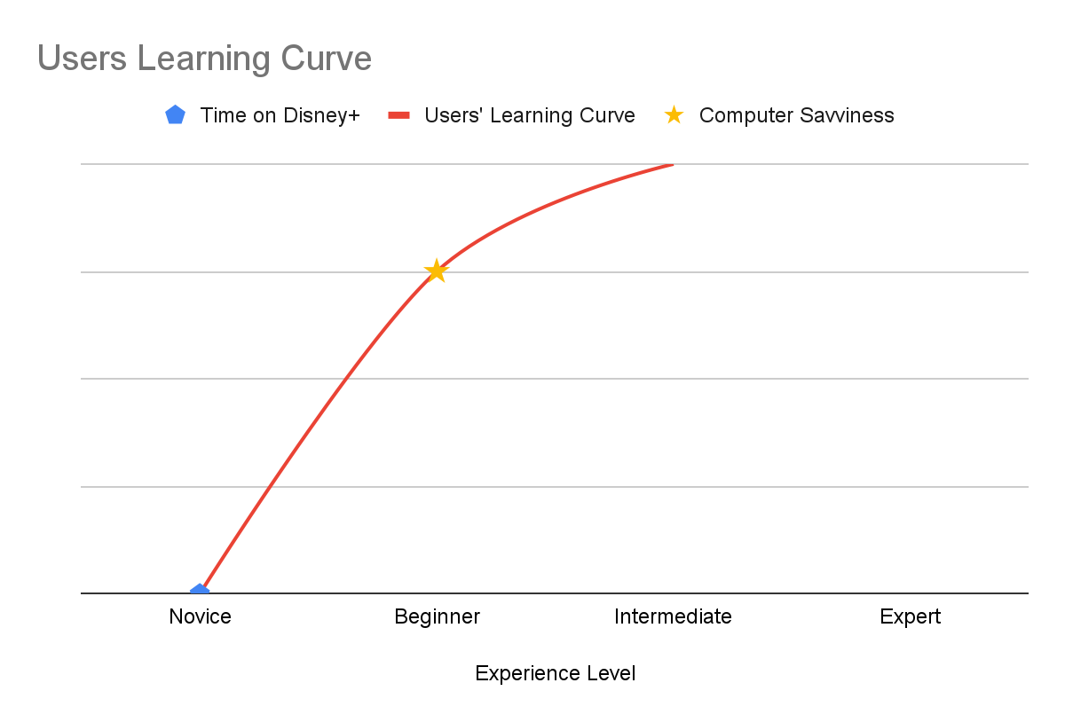

**Chart Description**

This chart displays the learning curve of the persona above.

This line shows the delta of no Experience on Disney+ versus the Persona’s Computer Savviness which gives the visual of the learning curve.